**IT 542: Pattern Recognition and Machine Learning**

**Assignment 3**

ID:201811024

Name- Rajat Kumar

1. **Check suitability of naïve-bayes classifier from Assignment-2 on IRIS data from UCI Machine Learning Repository. Consider 40 samples from each class as training data, use remaining 10 from each class as testing data. Perform 3-fold cross validation.**

**Code:**

from sklearn import datasets

from sklearn.model_selection import KFold

iris = datasets.load_iris()

from sklearn.naive_bayes import GaussianNB

gnb = GaussianNB()

y_pred = gnb.fit(iris.data, iris.target).predict(iris.data)

print("Number of mislabeled points out of a total %d points : %d" %(iris.data.shape[0],(iris.target != y_pred).sum()))

Output:

Number of mislabeled points out of a total 150 points : 6

# 3 fold validation

from sklearn.model_selection import KFold # import KFold

X =iris.data # create an array

Y = iris.target # Create another array

kf = KFold(n_splits=3,shuffle=True) # Define the split - into 2 folds

kf.get_n_splits(X) # returns the number of splitting iterations in the cross-validator

print(kf)

for train_index, test_index in kf.split(X):

X_train=X[train_index]

X_test=X[test_index]

Y_train=Y[train_index]

Y_test=Y[test_index]

y_pred = gnb.fit(X_train,Y_train).predict(X_test)

print("Number of mislabeled points out of a total %d points : %d" %(X_test.shape[0],(Y_test != y_pred).sum()))

num=(Y_test == y_pred).sum()

denom=X_test.shape[0]

print('Accuracy:',(num/denom)*100, '%')

**OUTPUT:**

Number of mislabeled points out of a total 50 points : 1

Accuracy: 98.0 %

Number of mislabeled points out of a total 50 points : 1

Accuracy: 98.0 %

Number of mislabeled points out of a total 50 points : 4

Accuracy: 92.0 %

**(2) Implement k-NN classifier and use it for IRIS data with k = 1, 3, 5 and 11. Perform 3-fold validation.**

import numpy as np

import pandas as pd

# Importing the dataset

dataset = pd.read_csv('iris.csv')

feature_columns = ['SepalLengthCm', 'SepalWidthCm', 'PetalLengthCm','PetalWidthCm']

X = dataset[feature_columns].values

y = dataset['Species'].values

from sklearn.preprocessing import LabelEncoder

le = LabelEncoder()

y = le.fit_transform(y)

from sklearn.cross_validation import train_test_split

X_train, X_test, y_train, y_test = train_test_split(X, y, test_size = 0.2, random_state = 0)

import matplotlib.pyplot as plt

import seaborn as sns

%matplotlib inline

from pandas.plotting import parallel_coordinates

plt.figure(figsize=(15,10))

parallel_coordinates(dataset.drop("Id", axis=1), "Species")

plt.title('Parallel Coordinates Plot', fontsize=20, fontweight='bold')

plt.xlabel('Features', fontsize=15)

plt.ylabel('Features values', fontsize=15)

plt.legend(loc=1, prop={'size': 15}, frameon=True,shadow=True, facecolor="white", edgecolor="black")

plt.show()

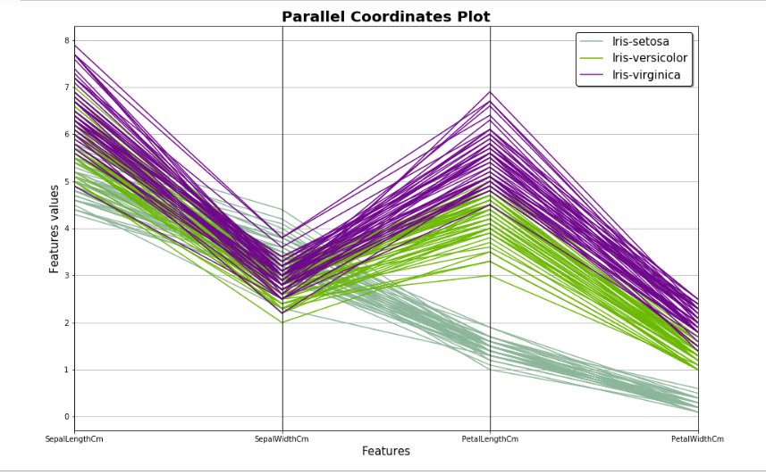

from pandas.plotting import andrews_curves

plt.figure(figsize=(15,10))

andrews_curves(dataset.drop("Id", axis=1), "Species")

plt.title('Andrews Curves Plot', fontsize=20, fontweight='bold')

plt.legend(loc=1, prop={'size': 15}, frameon=True,shadow=True, facecolor="white", edgecolor="black")

plt.show()

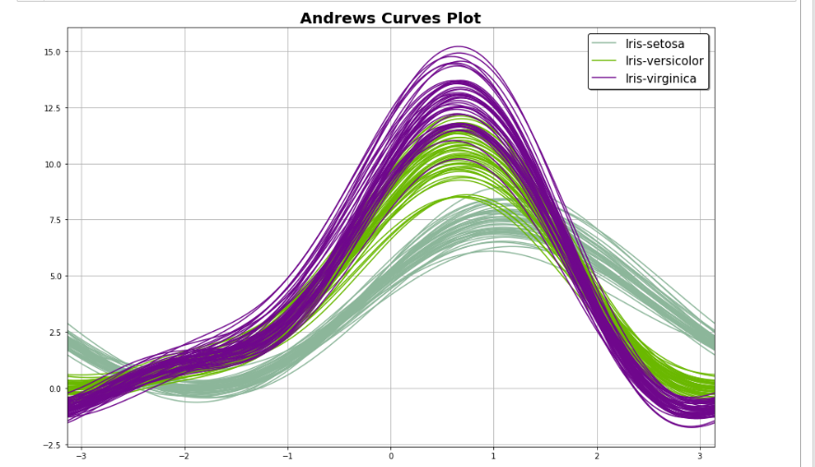

# Fitting clasifier to the Training set

# Loading libraries

from sklearn.neighbors import KNeighborsClassifier

from sklearn.metrics import confusion_matrix, accuracy_score

from sklearn.model_selection import cross_val_score

# Instantiate learning model (k = 3)

classifier = KNeighborsClassifier(n_neighbors=3) # 1,3,5,11

# Fitting the model

classifier.fit(X_train, y_train)

# Predicting the Test set results

y_pred = classifier.predict(X_test)

cm = confusion_matrix(y_test, y_pred)

Cm

accuracy = accuracy_score(y_test, y_pred)*100

print('Accuracy of our model is equal ' + str(round(accuracy, 2)) + ' %.')

Output:

**Accuracy of our model is equal 96.67 %.**

# creating list of K for KNN

k_list = list([1,3,5,11])

# creating list of cv scores

cv_scores = []

# perform 3-fold cross validation

for k in k_list:

knn = KNeighborsClassifier(n_neighbors=k)

scores = cross_val_score(knn, X_train, y_train, cv=3, scoring='accuracy')

cv_scores.append(scores.mean())

# changing to misclassification error

MSE = [1 - x for x in cv_scores]

plt.figure()

plt.figure(figsize=(15,10))

plt.title('The optimal number of neighbors', fontsize=20, fontweight='bold')

plt.xlabel('Number of Neighbors K', fontsize=15)

plt.ylabel('Misclassification Error', fontsize=15)

sns.set_style("whitegrid")

plt.plot(k_list, MSE,marker='o',markersize=12)

plt.show()

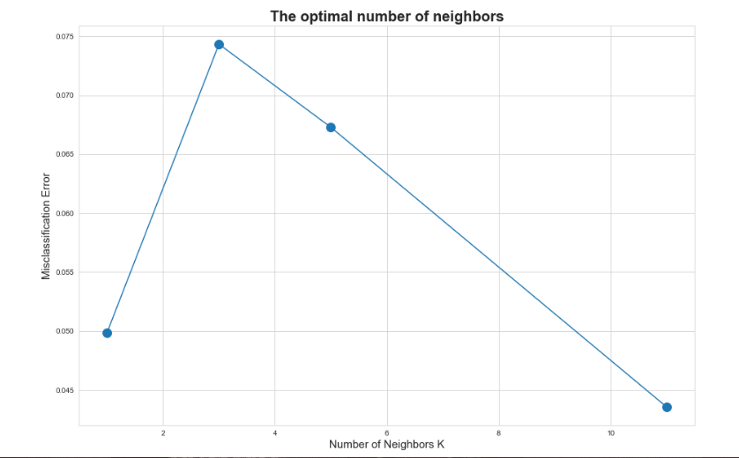

# finding best k

best_k = k_list[MSE.index(min(MSE))]

print("The optimal number of neighbors is %d." % best_k)

**OUTPUT:**

The optimal number of neighbors is 11.